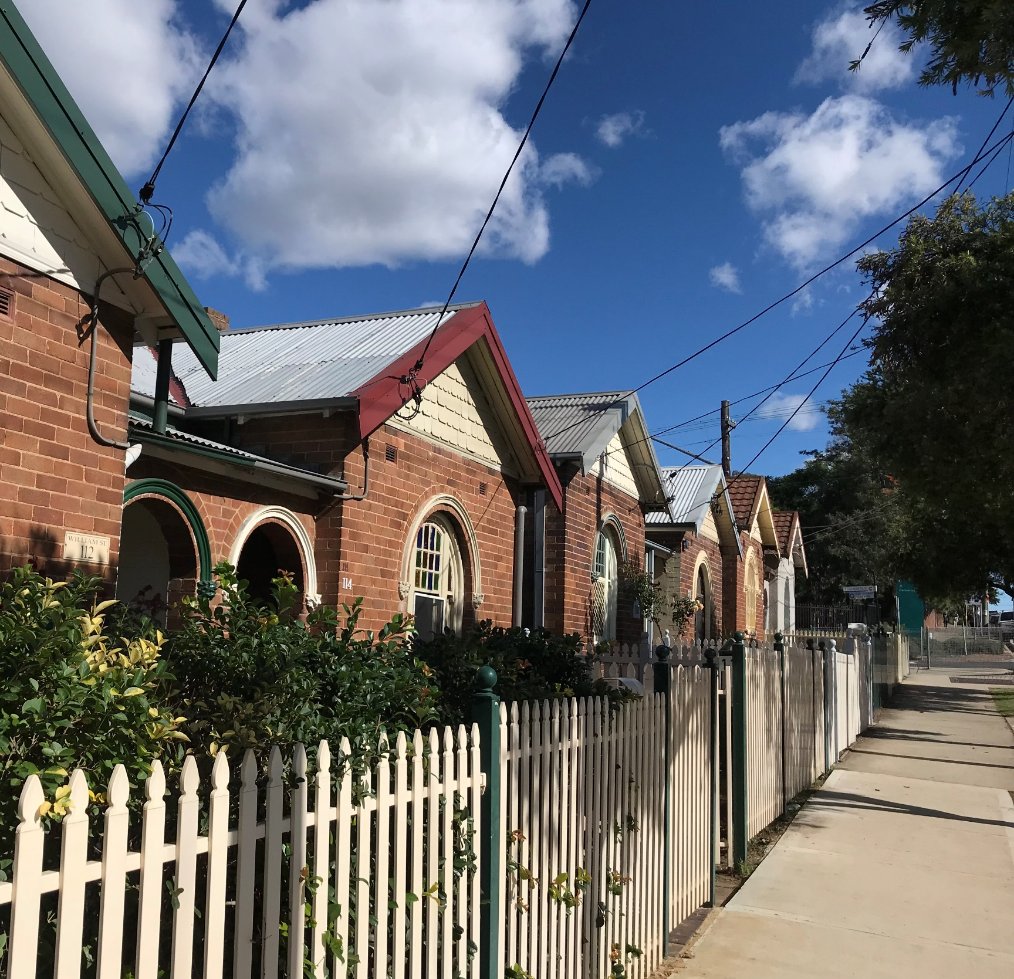
PLANNING PROPOSAL
CUMBERLAND HERITAGE STUDY

JANUARY 2023
CONTENTS
EXECUTIVE SUMMARY 3
PART 1 – OBJECTIVES AND INTENDED OUTCOMES 4
PART 2 – EXPLANATION OF PROVISIONS 5
PART 3 – JUSTIFICATION OF STRATEGIC AND SITE-SPECIFIC MERIT 14
Section A - need for the planning proposal 14
Section B – relationship to the strategic planning framework 15
Section C – environmental, social and economic impact 27
Section D – Infrastructure (Local, State and Commonwealth) 28
Section E – State and Commonwealth Interests 28
PART 4 – MAPS 29
PART 5 – COMMUNITY CONSULTATION 30
PART 6 – PROJECT TIMELINE 31

APPENDICES
Appendix 1 – Detailed Maps
Appendix 2 – Early Consultation Summary Report
Appendix 3a – Cumberland Local Planning Panel Report (dated 14 November 2023)
Appendix 3b- Cumberland Local Planning Panel Minutes (dated 14 November 2023)
Appendix 4a – Cumberland Council Meeting Report (dated 7 December 2023)
Appendix 4b – Cumberland Council Meeting Minutes (dated 7 December 2023)
Appendix 5 - Cumberland Comprehensive Heritage Study, Stage 1 – Main Report, Volume 1 (Stage 1 Report) prepared by Extent Heritage (dated 6 March 2020)
Appendix 6 - Cumberland Comprehensive Heritage Study, Stage 1 – Main Report, Volume 2 (Stage 1 Report) prepared by Extent Heritage (dated 6 March 2020)
Appendix 7 - Cumberland Comprehensive Heritage Study, Stage 1 – Main Report, Volume 3 (Stage 1 Report) prepared by Extent Heritage (dated 6 March 2020)
Appendix 8 – Cumberland Comprehensive Heritage Study, Stage 2 – Secondary Report, Volume 1 (Stage 2 Report) prepared by Extent Heritage (dated 6 March 2020)
Appendix 9 – Cumberland Comprehensive Heritage Study, Stage 2 – Secondary Report, Volume 2 (Stage 2 Report) prepared by Extent Heritage (dated 6 March 2020)
Appendix 10 – Peer Review of Comprehensive Heritage Study – Cumberland Heritage List prepared by Nimbus Architecture and Heritage (dated October 2022)

EXECUTIVE SUMMARY

This Planning Proposal explains the intent of, and justification for, proposed amendments to Cumberland Local Environmental Plan 2021 (the LEP) in relation to the Environmental Heritage schedule and Heritage Maps.
Cumberland City Council (Council) commissioned the Cumberland LGA Comprehensive Heritage Study (Heritage Study) with a focus on reviewing the status of existing heritage items and identification of new potential heritage items. On the 21 April 2021, Council carried a motion to proceed with a Planning Proposal to reflect the findings of the Heritage Study.
The Cumberland Local Planning Panel supported the Council officer recommendation for 47 amendments, 52 new heritage items and 3 new HCAs at an Extraordinary Meeting, held 14 November 2022 (refer Appendix 3).
Council resolved on the 7 December 2022 to progress with the proposed new heritage items where there had been no objections from any of the land owners during early consultation or removed at the Council meeting (refer Appendix 4).
This Planning Proposal reflects the Council resolution (dated 7 December 2022) and includes the following amendments to the Cumberland LEP 2021:
- Amend the curtilage and listing of forty-seven (47) existing heritage items listed within Part 1 of Schedule 5 of the LEP
- Add twenty-four (24) heritage items to Part 1 of Schedule 5 of the LEP
- Amend the Heritage Map in the Cumberland LEP 2021 to reflect the proposed changes to:
  - the curtilage (boundary) of forty-seven (47) existing heritage items
  - add the proposed twenty-four (24) heritage items
The form and content of this Planning Proposal complies with Section 3.33 of the Environmental Planning and Assessment Act 1979 and the LEP Making Guidelines (NSW Department of Planning and Environment, September 2022).

PART 1 – OBJECTIVES AND INTENDED OUTCOMES

The objective of this Planning Proposal is to improve the accuracy and operation of the Cumberland LEP 2021 and expand the conservation of heritage across the local government area (LGA) as identified in the Cumberland Council Comprehensive Heritage Study.

The intended outcomes of this Planning Proposal are:
- To update the heritage related provisions within the Cumberland LEP 2021 to reflect any changes in local conditions
- To recognise the local heritage significance of various properties and areas across the Cumberland LGA
- To protect and conserve the items identified as having heritage significance through statutory and regulatory instruments
- To contribute to the cultural value and history of the local area.

PART 2 – EXPLANATION OF PROVISIONS

This Planning Proposal involves an amendment to Parts 1, 2 and 3 of Schedule 5 of the Cumberland Local Environmental Plan 2021 and adjustment to the Heritage Map series.
The intended provisions are:
- Amend the curtilage and information of forty-seven (47) existing heritage items listed within Part 1 of Schedule 5 of the LEP
- Amend Part 1 of Schedule 5 of the LEP to add twenty-four (24) new items.
- Amend the Cumberland LEP 2021 – Heritage Map to include the additional Part 1 items
- Amend the Cumberland LEP 2021 – Heritage Map to reflect the revised curtilage of certain existing items.
Table 1a and 1b identify all heritage items being adjusted and which map number they are located on.
The maps in Figure 1 and Appendix 1 graphically illustrate the location of the amendments sought to heritage controls as part of this Planning Proposal.
The items mapped are categorised as follows:
- Existing items with no changes shown green
- Existing items where curtilage / information amended shown blue
- Proposed new heritage items shown brown

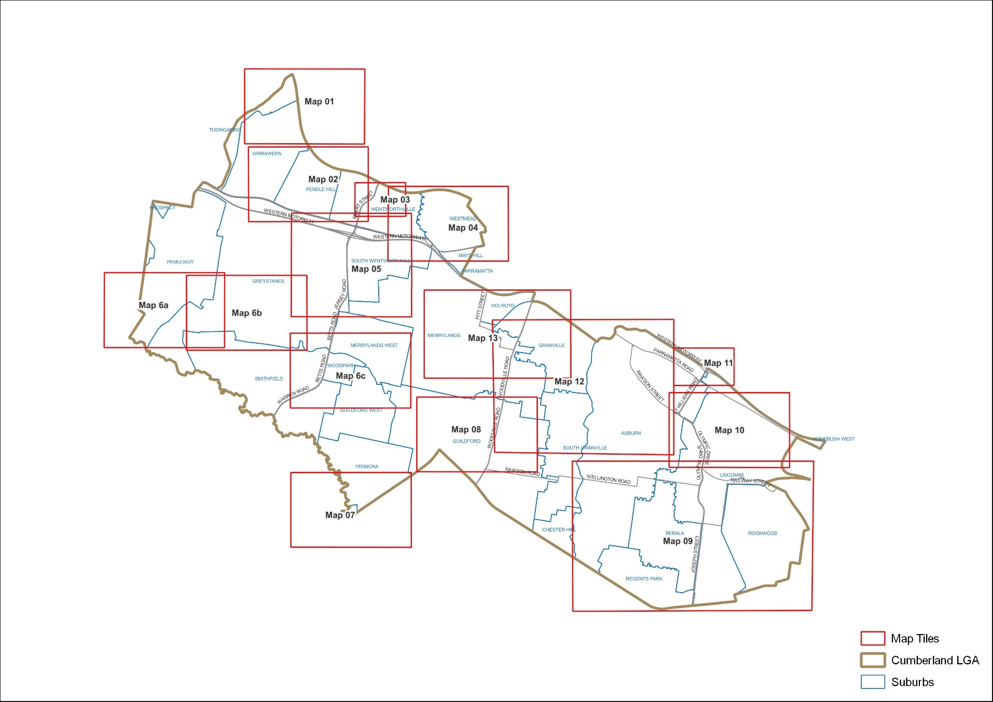
Figure 1: Map Tile Legend
Table 1a: Stage 1 – Amendments
CLEP Item ID | Name of Item | Address | Map Tile | Description
A01023 | Auburn Signal Box | Rawson Street, opposite Karrabah Road, Auburn | Map 12 | Curtilage amendment and name update
A1 | Auburn War Memorial | Northumberland Road, RSL car park (opposite the Auburn RSL), Auburn | Map 10, 12 | No Curtilage amendment and name update
A2, A3 | Parramatta Road Milestone | South side of Parramatta Road between Dartbrook and Station Roads, Auburn and Lidcombe | Map 11 | Curtilage amendment and name update
 | Parramatta Road Milestone | South side of Parramatta Road, east of Station Road, east of Delhi Street, east side of railway bridge abutments near Birnie Street | Map 12 | Curtilage amendment and name update
A4 | Clyde Marshalling Yards | Rawson Street, Auburn | Map 12 | Curtilage amendment, listing combination and name update
A5 | Berala railway station | Campbell Street, Berala | Map 09 | Curtilage amendment
A6 | Former Farm, Hyland Road Inn and former post office | Hyland Road, Greystanes | Map 6a | Curtilage amendment and name update
I01945, I128 | Footbridge over Lower Prospect Canal | Albert Street, Greystanes;  Guildford and Guildford West | Map 6a,6b,6c | Curtilage amendment, listing combination and name update
 | Boothtown Aqueduct | Macquarie Road (between Alpha Road and Dahlia Street) | Map 6a,6b,6c | Curtilage amendment, listing combination and name update
A1 6 | Railway viaduct site | Portico Parade (Toongabbie Railway Station), Toongabbie | Map 01 | Curtilage amendment, name update and listing combination
I105 | The Trongate Victorian Group | "90, 92, 94, 96, 98 and 100p102 The Trongate", Granville | Map 12, 13 | Curtilage amendment and name update
I11 | Uniting Church Auburn Parish and adjacent Victory Hall | Northeast corner of Helena Street and Harrow Road, Auburn | Map 12 | Curtilage amendment and name update
I156 | Late Victorian cottage | 63 O Neill Street, Guildford | Map 08 | Curtilage amendment and name update
I165 | Late Victorian/Federation residence | 9A Tennyson Parade, Guildford | Map6c | Curtilage amendment and name update
I167 | Federation period cottage | 20A The Esplanade, Guildford | Map 08 | Curtilage amendment and name update
I171, I220 | Milestone | Adjacent to 198 Woodville Road;  Guildford and Merrylands | Map 08, 12, 13 | No Curtilage amendment, listing combination and name update
I175, I187 | Wyatt Park, Haslams Creek, Lidcombe Pool, Lidcombe Oval, Stormwater Drain | (Main entrance) at Church Street, Lidcombe | Map 09, 10 | Curtilage amendment, listing combination and name update
I178 | Dwelling | 24 James Street, Lidcombe | Map 09 | Curtilage amendment and name update
I183 | Minali Special School (early twentieth century residence) | Off Joseph Street, Lidcombe | Map 09 | Curtilage amendment and name update
I185 | Fenton House | 35-47 Joseph Street, Lidcombe | Map 09 | Curtilage amendment and name update
I186 | Dwelling | 53-55 Kerrs Road, Lidcombe | Map 09 | Curtilage amendment and name update
I188 | Stand of Eucalyptus longifolia | Corner of Parramatta and Hill Roads, Lidcombe | Map 10 | Curtilage amendment and name update
I20 | Horse trough | Corner of Water Street and Auburn Road, Auburn | Map 09 | Curtilage amendment and administration
I202 | Late Victorian cottage/  Cumberland Model Farms Estate | 130 Jersey Road, Merrylands | Map 05 | Curtilage amendment and administration
I209 | Electrical substation | 285 Merrylands Road, Merrylands | Map 13 | Curtilage amendment and name update
I212 | Merrylands Railway Station | Military Road, Merrylands | Map 13 | Curtilage Amendment
I219 | Federation period cottage | 33 Walker Street, Merrylands | Map 13 | Curtilage amendment and name update
I228 | Former Bonds Bobbin Mill facade | 211-215 Dunmore Street, Wentworthville | Map 02 | Curtilage amendment
I23 | St Peter Chanel School Hall, Church and Rectory | 60 66 Kingsland Road, Berala | Map 09 | Curtilage amendment and name update
I231 | Pendle Hill Railway Station | Pendle Way, Pendle Hill | Map 02 | Curtilage amendment and name update
I233 | Regents Park railway station | Park Road, Regents Park | Map 09 | Curtilage amendment
I237 | Houses built for Housing Commission | 27, 29, 33, 35, 37, 39, 41, 43 and 47 Chiswick Road, South Granville | Map 12 | Curtilage amendment and name update
I238 | Houses built for Housing Commission | 278, 286 and 288 Clyde Street, South Granville | Map 12 | Curtilage amendment and name update
I247, I249 | Toongabbie Railway Station | Cornelia Road, Toongabbie | Map 01 | Curtilage amendment, listing combination and name update
I26 | Targo Mahal, Federation bungalow | 156 Targo Road, Girraween | Map 01 | Curtilage amendment and name update
I268 | Electricity Substation | 62 Fullagar Road, Wentworthville | Map 04, 05 | Curtilage Amendment
I271 | Inter-war bungalow | 32 Garfield Street, Wentworthville | Map 03 | Curtilage amendment and name update
I274 | Nelyambo, Federation period bungalow | 42 Garfield Street, Wentworthville | Map 03 | Curtilage amendment and name update
I282 | Wentworthville Railway Station | The Kingsway, Wentworthville | Map 04 | Curtilage amendment, Listing combination and name update
I287 | Allengreen, Federation bungalow | 1 Amos Street (also known as 14 The Park or 1 Thomas May Place), Westmead | Map 04 | Curtilage amendment and name update
I3 | Jack Lang Plaque | 4 Auburn Road, Auburn | Map 12 | Curtilage amendment
I308 | Inter-war (Mediterranean influences) apartment block | 15-17 The Park (also known as 15-17 Thomas May Place), Westmead | Map 04 | Curtilage amendment and name update
I309 | Yennora Railway Station | Nelson Road, Yennora | Map 07 | Curtilage amendment and name update
I41 | Holy Trinity Church Group | 40 Grimwood Street, Granville | Map 12, 13 | Curtilage amendment
I44 | Single storey residence | 6 Hewlett Street, Granville | Map 12, 13 | Curtilage amendment and name update
I67 | Single storey residence | 8 Mary Street, Granville | Map 13, 14 | Curtilage amendment and name update
I71 | Granville War Memorial | 1 Memorial Drive, Granville | Map 12 | Curtilage amendment and name update
I75 | New York Street Group | "12, 13, 14, 18, 20, 22 and 24 New York Street", Granville | Map 12, 13 | Curtilage amendment and name update
I80 | Single storey residence | 70 Railway Parade, Granville | Map 13 | Curtilage amendment

Table 1b: Stage 2 – Proposed new heritage items
CLEP Item ID | Name of Item | Address | Map Tile
HS2 | Former Auburn Post Office | Cnr Auburn Road and Kerr Parade, Auburn | Map 12
HS3 | Pritchard's Building | 6-14 Auburn Road, Auburn | Map 12
HS4 | Federation Shopfronts | 23 and 25 Auburn Road, Auburn | Map 12
HS5 | Late Victorian Shopfront | 60-62 Auburn Road, Auburn | Map 12
HS7 | Federation Queen Anne Residence | 151 Auburn Road, Auburn | Map 12
HS10 | Auburn Gallipoli Mosque | 1 - 19 Gelibolu Road, Auburn | Map 10, 12
HS18 | Federation Bungalow | 59 Mary Street, Auburn | Map 12
HS22 | Melton Hotel | 135 Parramatta Road, Auburn | Map 11, 12
HS24 | Warehouse | 259-263 Parramatta Road | Map 12
HS25 | Auburn Hotel | 43 Queen Street, Auburn | Map 12
HS26 | Auburn Presbyterian Church | 29 Queen Street, Auburn | Map 10, 12
HS27 | St John of God Catholic Church and St John's Catholic Primary School | 73-77 Queen Street, 82-84 Queen Street, 2 Alice Street, Auburn | Map 12
HS41 | Headstone and Memorials | Factory Street, western side, near Clyde Railway Station, Clyde | Map 12
HS44 | 8 Hewlett Street | 8 Hewlett Street, Granville | Map 12,13
HS46 | Victorian Cottage | 32 The Avenue, Granville | Map 13
HS48 | St Aphanasius Ukrainian Orthodox Church and Hall | 45 William Street, Granville | Map 12, 13
HS51 | Post-War Austerity Style House | 38 Bolton Street, Guildford | Map 08
HS52 | Federation Bungalow | 214 Guildford Road, Guildford | Map 08
HS67 | St Andrew's Ukrainian War Memorial Church | 27-29 Mary Street, Lidcombe | Map 09
HS71 | Former Jantzen Swimwear Factory | 32 - 43 Parramatta Road, Lidcombe | Map 10
HS74 | Eldridge's Buildings' - Federation Shopfronts | 36-40 Railway Street, Lidcombe | Map 09
HS75 | Russian Old Rite Orthodox Christian Church | 56-60 Vaughan Street, Lidcombe | Map 09
HS78 | Victorian Weatherboard Cottage | 30 Abbott Street, Merrylands | Map 12
HS79 | Federation Bungalow | 291 Merrylands Road, Merrylands | Map 13

PART 3 – JUSTIFICATION OF STRATEGIC AND SITE-SPECIFIC MERIT

Section A. Need for the planning proposal

Is the planning proposal a result of an endorsed LSPS, strategic study or report?
Yes, this Planning Proposal implements the findings of Cumberland Council Comprehensive Heritage Study (the Heritage Study).
In 2016, following the proclamation of Cumberland City Council, a need was identified to update and improve the reference information and management tools related to protecting and managing local heritage.
On 7 September 2016, Cumberland City Council resolved to prepare a Heritage Study (report item 079/16). Consequently, Extent Heritage Advisors were engaged to complete the Heritage Study and produced:
- Cumberland LGA Comprehensive Heritage Study, Stage 1 – Main Report, Volumes 1-3 (Stage 1 Report) – Refer Appendices 5, 6 and 7.
- Cumberland LGA Comprehensive Heritage Study, Stage 2 – Secondary Report, Volumes 1 and 2 (Stage 2 Report) – Refer Appendices 8 and 9.
The Stage 1 Report:
- established a thematic history of the LGA,
- reviewed the existing heritage items within the boundaries of the LGA,
- outlined potential items for delisting and/or items for State Heritage Register Nomination,
- identified areas that required further heritage documentation, and
- produced mapping.
The Stage 2 Report provided an assessment of the heritage significance of the proposed new heritage items and heritage conservation areas (HCAs) with recommendations on which should be included in the LEP’s Heritage List. The Stage 2 report was supported by the provision of Heritage Inventory Sheets for the items and HCAs.
On 21 April 2021, Council resolved to endorse the findings of the Heritage Study (both the Stage 1 and Stage 2 Reports) and prepare a Planning Proposal to reflect the findings.
Following Council endorsement of this approach, initial work focused on reviewing and refining the recommendations for potential new heritage listings that came from the Stage 2 Report. This resulted in a short list of:
- Stage 1: 63 curtilage item amendments;
- Stage 2: 63 potential new items; and 5 potential heritage conservation areas.
These refined recommendations were placed on public exhibition for early community consultation during June-August 2021 (part 5 of this Planning Proposal summarises feedback from the early public consultation).
After the completion of the community consultation, Nimbus Architecture and Heritage was engaged in January 2022 to provide an independent peer review of the Stage 2 heritage recommendations including a review of the submissions received during public consultation. Nimbus Architecture and Heritage collaborated with DFP Planning to undertake the peer review (refer Appendix 10).
The outcomes of the independent peer review, which considered the original Stage 2 recommendations and community submissions, suggested the following progress:
- Stage 1 – Amend 62 heritage items.
- Stage 2 – Add 64 heritage items, 4 new HCAs and extend 1 HCA.
Based on the outcomes of the independent peer review, community feedback and a public benefit analysis by Council, Council officers supported progressing the following:
- Stage 1 – Amend 47 heritage items
- Stage 2 – Add 52 heritage items and 3 new HCAs
- Separate Planning Proposal for the 11 heritage items and 2 heritage conservation areas located within the Westmead South Master Plan study area to holistically consider them as part of the place-based planning process. (for updates on the Westmead project please refer to https://haveyoursay.cumberland.nsw.gov.au/westmead-south).
The Cumberland Local Planning Panel supported the Council officer recommendation for 47 amendments, 52 new heritage items and 3 new HCAs at an Extraordinary Meeting, held 14 November 2022 (refer Appendix 3).
As seen in Appendix 4, Council resolved on the 7 December 2022 to progress with the proposed new heritage items where there had been no objections from any of the land owners during early consultation or removed at the Council meeting. The Council resolution provided the following recommendations as outlined in this planning proposal:
- Stage 1 – Amend 47 heritage items
- Stage 2 – Add 24 new heritage items.

Is the planning proposal the best means of achieving the objectives or intended outcomes, or is there a better way?
Yes, this Planning Proposal is the best means of achieving the objectives and intended outcomes which is to ensure that there are appropriate legislative and regulatory planning controls to protect and conserve heritage within the Cumberland LGA. The proposed changes to the LEP are supported by a Heritage Study, an independent peer review of that study and early community consultation.

Section B – relationship to the strategic planning framework

Will the planning proposal give effect to the objectives and actions of the applicable regional or district plan or strategy (including any exhibited draft plans or strategies)?
Greater Sydney Region Plan
The Greater Sydney Region Plan outlines a vision for Sydney to 2056 as a global metropolis of three cities – Western Parkland City, Central River City and Eastern Harbour City.
The Planning Proposal is generally consistent with the following planning objectives of the Greater Sydney Region Plan as highlighted in Table 2.

Table 2. Consistency with Greater Sydney Region Plan
Direction | Consistency
Objective 1:  Infrastructure supports the three cities | The Planning Proposal is consistent with the Objective.
Objective 2:  Infrastructure aligns with forecast growth – growth infrastructure compact | The Planning Proposal is consistent with the Objective.
Objective 3:  Infrastructure adapts to meet future needs | The Planning Proposal is consistent with the Objective.
Objective 4:  Infrastructure use is optimised | The Planning Proposal is consistent with the Objective.
Objective 5:  Benefits of growth realised by collaboration of governments, community and business | The Planning Proposal is consistent with the Objective.
Objective 6:  Services and infrastructure meet communities’ changing needs | The Planning Proposal is consistent with the Objective.
Objective 7:  Communities are healthy, resilient and socially connected | The Planning Proposal is consistent with the Objective.
Objective 8:  Greater Sydney’s communities are culturally rich with diverse neighbourhoods | The Planning Proposal is consistent with the Objective.
Objective 9:  Greater Sydney celebrates the arts and supports creative industries and innovation | The Planning Proposal is consistent with the Objective.
Objective 10:  Greater housing supply | Council’s Local Housing Strategy identifies opportunities for the delivery of housing supply. This Planning Proposal will not hinder the delivery of the Local Housing Strategy’s outcomes.  The existing DCP ensures that applicable provisions support appropriate development of heritage items.
Objective 11:  Housing is more diverse and affordable | Council’s Local Housing Strategy identifies opportunities for the delivery of housing supply. This Planning Proposal will not hinder the delivery of the Local Housing Strategy’s outcomes and support the Planning Priorities outlined in Cumberland 2030: Our Local Strategic Planning Statement.
Objective 12:  Great places that bring people together | The Planning Proposal is consistent with the Objective.
Objective 13:  Environmental heritage is identified, conserved and enhanced | This PP directly supports Objective 13 which outlines the need to identify, conserve and enhance environmental heritage Council has undertaken considerable community consultation to build awareness of heritage values and benefits of improved heritage conservation across the LGA (Refer to Part 3, Section A of PP).  On balance, the community has been predominantly supportive of implementing the findings of the Heritage Study to protect places of historical significance. Additional community consultation is proposed following Gateway Determination.
Objective 14:  A Metropolis of Three Cities – integrated land use and transport creates walkable and 30-minute cities | The Planning Proposal is consistent with the Objective.
Objective 15:  The Eastern, GPOP and Western Economic Corridors are better connected and more competitive | The Planning Proposal is consistent with the Objective.
Objective 16:  Freight and logistics network is competitive and efficient | The Planning Proposal is consistent with the Objective.
Objective 17:  Regional connectivity is enhanced | This Objective does not apply to the Planning Proposal.
Objective 18:  Harbour CBD is stronger and more competitive | This Objective does not apply to the Planning Proposal.
Objective 19:  Greater Parramatta is stronger and better connected | The Planning Proposal is consistent with the Objective.
Objective 20:  Western Sydney Airport and Badgerys Creek Aerotropolis are economic catalysts for Western Parkland City | This Objective does not apply to the Planning Proposal.
Objective 21:  Internationally competitive health, education, research and innovation precincts | The Planning Proposal is consistent with the Objective.
Objective 22:  Investment and business activity in centres | The Planning Proposal is consistent with the Objective.
Objective 23:  Industrial and urban services land is planned, retained and managed | The Planning Proposal is consistent with the Objective.
Objective 24:  Economic sectors are targeted for success | The Planning Proposal is consistent with the Objective.
Objective 25:  The coast and waterways are protected and healthier | The Planning Proposal is consistent with the Objective.
Objective 26:  A cool and green parkland city in the South Creek corridor | This Objective does not apply to the Planning Proposal.
Objective 27:  Biodiversity is protected, urban bushland and remnant vegetation is enhanced | The Planning Proposal is consistent with the Objective.
Objective 28:  Scenic and cultural landscapes are protected | The Planning Proposal is consistent with the Objective.
Objective 29:  Environmental, social and economic values in rural areas are protected and enhanced | The Planning Proposal is consistent with the Objective.
Objective 30:  Urban tree canopy cover is increased | The Planning Proposal is consistent with the Objective.
Objective 31:  Public open space is accessible, protected and enhanced | The Planning Proposal is consistent with the Objective.
Objective 32:  The Green Grid links parks, open spaces, bushland and walking and cycling paths | The Planning Proposal is consistent with the Objective.
Objective 33:  A low-carbon city contributes to net-zero emissions by 2050 and mitigates climate change | The Planning Proposal is consistent with the Objective.
Objective 34:  Energy and water flows are captured, used and re-used | The Planning Proposal is consistent with the Objective.
Objective 35:  More waste is re-used and recycled to support the development of a circular economy | The Planning Proposal is consistent with the Objective.
Objective 36:  People and places adapt to climate change and future shocks and stresses | The Planning Proposal is consistent with the Objective.
Objective 37:  Exposure to natural and urban hazards is reduced | The Planning Proposal is consistent with the Objective.
Objective 38:  Heatwaves and extreme heat are managed | The Planning Proposal is consistent with the Objective.

Central City District Plan
The Central City District Plan sets out the aspirations and priorities for liveability, productivity, and sustainability within the Central City District. Significant population growth is anticipated over the next 20 years, and this is expected to transform many parts of the district from a suburban to an urban environment.
The Planning Proposal is generally consistent with the directions and objectives of the Central City District Plan as highlighted in Table 3.

Table 3. Consistency with Central City District Plan
Direction | Planning Priority | Consistency
A collaborative city | Working through collaboration | The Planning Proposal is consistent with the Planning Priority.
A city supported by infrastructure | Planning for a city supported by infrastructure | The Planning Proposal is consistent with the Planning Priority.
A city for people | Providing services and social infrastructure to meet people’s changing needs | The Planning Proposal is consistent with the Planning Priority.
 | Fostering healthy, creative, culturally rich and socially connected communities | The Planning Proposal is consistent with the Planning Priority.
Housing the city | Providing housing supply, choice and affordability with access to jobs, services and public transport | Council’s Local Housing Strategy identifies opportunities for the delivery of housing supply. This Planning Proposal will not hinder the delivery of the Local Housing Strategy’s outcomes.  The existing DCP ensures that applicable provisions support appropriate development of heritage items.  Council has undertaken early consultation with the community (as discussed within Part 5) to ensure the Planning Proposal does not inhibit significant housing opportunities.
A city of great places | Creating and renewing great places and local centres, and respecting the District’s heritage | The Planning Proposal is consistent with this Direction as it will protect sites that have cultural significance by affording them additional protection through their inclusion within the heritage schedule. Preserving heritage items is an important component of place making and creating desirable spaces.
A well-connected city | Delivering integrated land use and transport planning and a 30-minute city | The Planning Proposal is consistent with the Planning Priority.
Jobs and skills for the city | Growing a stronger and more competitive Greater Parramatta | The Planning Proposal is consistent with the Planning Priority.
 | Delivering a more connected and competitive GPOP economic corridor | The Planning Proposal is consistent with the Planning Priority.
 | Growing investment, business and job opportunities in strategic centres | The Planning Proposal is consistent with the Planning Priority.
 | Maximising opportunities to attract advanced manufacturing and innovation in industrial and urban services land | The Planning Proposal is consistent with the Planning Priority.
 | Supporting growth of targeted industry sectors | The Planning Proposal is consistent with the Planning Priority.
A city in its landscape | Protecting and improving the health and enjoyment of the District’s waterways | This Direction does not apply to the Planning Proposal.
 | Creating a Parkland City urban structure and identity, with South Creek as a defining spatial element | This Direction does not apply to the Planning Proposal.
 | Protecting and enhancing bushland, biodiversity and scenic and cultural landscapes | The Planning Proposal is consistent with the Planning Priority.
 | Increasing urban tree canopy cover and delivering Green Grid connections | This Direction does not apply to the Planning Proposal.
 | Delivering high quality open space | The Planning Proposal is consistent with the Planning Priority.
 | Better managing rural areas | The Planning Proposal is consistent with the Planning Priority.
A resilient city | Adapting to the impacts of urban and natural hazards and climate change | This Direction does not apply to the Planning Proposal.
An efficient city | Reducing carbon emissions and managing energy, water and waste efficiently | This Direction does not apply to the Planning Proposal.

Is the planning proposal consistent with a council LSPS that has been endorsed by the Planning Secretary or GSC, or another endorsed local strategy or strategic plan?

Cumberland 2030: Our Local Strategic Planning Statement
The LSPS, Cumberland 2030, was endorsed by the Greater Sydney Commission on the 4 March 2020.
Cumberland 2030 is aligned with the Greater Sydney Region Plan and Central City District Plan, providing a strategic, coordinated approach to effectively manage growth and development in the local area.
The Planning Proposal is consistent with Cumberland 2030: Our Local Strategic Planning Statement as demonstrated in Table 4.

Table 4. Consistency with Cumberland 2030: Our Strategic Planning Statement
Priority | Consistency
Planning Priority 1:  Strengthening Cumberland’s position in the District through collaboration | The Planning Proposal is consistent with this Planning Priority.
Planning Priority 2:  Advocating for a range of transport options that connect our town centres and employment hubs, both locally and to Greater Sydney | This Planning Priority does not apply to this Planning Proposal.
Planning Priority 3:  Aligning local infrastructure delivery with planned growth healthy living | This Planning Priority does not apply to this Planning Proposal.
Planning Priority 4:  Improving accessibility within our town centres | The Planning Proposal is consistent with this Planning Priority.
Planning Priority 5:  Delivering housing diversity to suit changing needs | The Planning Proposal is consistent with this Planning Priority.
Planning Priority 6:  Delivering affordable housing suitable for the needs of all people at various stages of their lives | The Planning Proposal is consistent with this Planning Priority.
Planning Priority 7:  Design vibrant and attractive centres and encourage healthy living | The Planning Proposal is consistent with this Planning Priority.
Planning Priority 8:  Celebrating our natural, built and cultural diversity | Planning Priority 8 recognises Council’s intent to celebrate the existing and future cultural diversity in Cumberland, including through the built form. The LSPS identified that Council will continue to plan and develop strategies that support cultural celebration and diversity, including the intent to “review heritage items and consideration of new items as part of an integrated approach for Cumberland”.  The delivery of this Planning Proposal is consistent with the intent identified above and is consistent with Council’s Planning Priority 8 action (i):  “Support Cumberland’s natural, built and cultural diversity through Council’s strategies, plans and programs, including protecting listing under the Cumberland Local Environmental Plan and the State Heritage Act”
Planning Priority 9:  Providing high quality, fit-for-purpose community and social infrastructure in line with growth and changing requirements | The Planning Proposal is consistent with this Planning Priority.
Planning Priority 10:  Supporting a strong and diverse local economy across town centres and employment hubs | The Planning Proposal is consistent with this Planning Priority.
Planning Priority 12:  Facilitating the evolution of employment and innovation lands to meet future needs | The Planning Proposal is consistent with this Planning Priority.
Planning Priority 13:  Protecting, enhancing and increasing natural and green spaces | This Planning Priority does not apply to this Planning Proposal.
Planning Priority 14:  Improving access to and health of waterways | This Planning Priority does not apply to this Planning Proposal.
Planning Priority 15:  Planning for a resilient city that can adapt to natural hazards and climate change | This Planning Priority does not apply to this Planning Proposal.
Planning Priority 16:  Supporting urban cooling to minimise heat island effects | This Planning Priority does not apply to this Planning Proposal.

Cumberland Community Strategic Plan 2017-2027
Cumberland Community Strategic Plan 2017-2027 identifies the Cumberland communities’ vision for the social, environmental, and economic development in the LGA. It includes six (6) strategic goals and eighteen (18) desired outcomes.
The relevant strategic goals and capacity for this Planning Proposal to support these goals are outlined in Table 5.

Table 5. Consistency with Cumberland Council Strategic Plan 2017-2027
Strategic Goal | Outcome | Consistency
Strategic Goal 1  Supporting Community, Health, Safety and Wellbeing | A strong community and culture | The Planning Proposal is consistent with this Strategic Goal.
 | A safe healthy and active community | The Planning Proposal is consistent with this Strategic Goal.
Strategic Goal 2  Enhancing the Natural and Built Environment | Celebrate our diverse built and natural environments | The Planning Proposal will provide additional protection of places of heritage significance within the Cumberland LGA through the inclusion of these items within relevant LEP heritage schedules. The Planning Proposal is consistent with this Strategic Goal.
 | Places and spaces that are vibrant and connect us | The Planning Proposal is consistent with this Strategic Goal.
Strategic Goal 3  Delivering Sustainable Infrastructure and Services | We have public spaces that are welcoming, inclusive and promote pride in the area | The Planning Proposal is consistent with this Strategic Goal.
 | We have recreational assets that enhance the liveability of our community | The Planning Proposal is consistent with this Strategic Goal.
 | A clean and safe place to live | The Planning Proposal is consistent with this Strategic Goal.
Strategic Goal 4  Providing Local Leadership | The community is proud to be served by a sustainable and transparent Council organisation | The Planning Proposal is consistent with this Strategic Goal.
 | An informed community included in decision making and long-term planning | The Planning Proposal is consistent with this Strategic Goal. This is supported by the early consultation that has been undertaken on the new items and HCAs proposed within this Planning Proposal.

Cumberland Local Housing Strategy 2020
The Cumberland Local Housing Strategy identifies the need for Cumberland to accommodate an additional 28,500 dwellings by 2036.
This Planning Proposal will not inhibit housing delivery as it will not apply heritage provisions to sites of significant development opportunity. The Planning Proposal will not directly impact on Council’s ability to accommodate the necessary dwellings to support the growing population.

Is the planning proposal consistent with any other applicable State and regional studies or strategies?
There are no other applicable state or regional studies.

Is the planning proposal consistent with applicable SEPPs?
The Planning Proposal is consistent with the applicable State Environmental Planning Policies (SEPPs), as demonstrated in Table 6.

Table 6. Consistency with State Environmental Planning Policy
State Environmental Planning Policy | Statement of alignment
State Environmental Planning Policy (Biodiversity and Conservation) 2021 | Consistent
State Environmental Planning Policy (Exempt and Complying Development Codes) 2008 | Consistent
State Environmental Planning Policy (Industry and Employment) 2021 | Consistent
State Environmental Planning Policy (Planning Systems) 2021 | Consistent
State Environmental Planning Policy (Precincts—Central River City) 2021 | Consistent
State Environmental Planning Policy (Precincts—Eastern Harbour City) 2021 | Not applicable.
State Environmental Planning Policy (Precincts—Regional) 2021 | Not applicable.
State Environmental Planning Policy (Precincts—Western Parkland City) 2021 | Not applicable.
State Environmental Planning Policy (Primary Production) 2021 | Not applicable.
State Environmental Planning Policy (Resilience and Hazards) 2021 | Consistent
State Environmental Planning Policy (Resources and Energy) 2021 | Not applicable.
State Environmental Planning Policy (Transport and Infrastructure) 2021 | Consistent

Is the planning proposal consistent with applicable Ministerial Directions (section 9.1 Directions)?
The Planning Proposal is consistent with the relevant Ministerial Directions as demonstrated in Table 7.

Table 7. Consistency with Ministerial Directions
Ministerial Direction | Statement of alignment
Focus area 1: Planning Systems
1.1 Implementation of Regional Plans | This Planning Proposal is consistent with the Regional and Central District Plans as described in Tables 1 and 2.
1.2 Development of Aboriginal Land Council land | Not applicable
1.3 Approval and Referral Requirements | Consistent
1.4 Site Specific Provisions | Not applicable
Focus area 1: Planning Systems – Place-based
1.5 Parramatta Road Corridor Urban Transformation Strategy | Consistent - the planning proposal achieves the overall intent of the Parramatta Road Corridor Urban Transformation Strategy and does not undermine the achievement of its objectives, principles and priorities.
1.6 Implementation of North West Priority Growth Area Land Use and Infrastructure Implementation Plan | Not applicable
1.7 Implementation of Greater Parramatta Priority Growth Area Interim Land Use and Infrastructure Implementation Plan | Consistent - the planning proposal achieves the overall intent of the interim Plan and does not undermine the achievement of its objectives, planning principles and priorities for the Greater Parramatta Priority Growth Area.
1.8 Implementation of Wilton Priority Growth Area Interim Land Use and Infrastructure Implementation Plan | Not applicable
1.9 Implementation of Glenfield to Macarthur Urban Renewal Corridor | Not applicable
1.10 Implementation of the Western Sydney Aerotropolis Plan | Not applicable
1.11 Implementation of Bayside West Precincts 2036 Plan | Not applicable
1.12 Implementation of Planning Principles for the Cooks Cove Precinct | Not applicable
1.13 Implementation of St Leonards and Crows Nest 2036 Plan | Not applicable
1.14 Implementation of Greater Macarthur 2040 | Not applicable
1.15 Implementation of the Pyrmont Peninsula Place Strategy | Not applicable
1.16 North West Rail Link Corridor Strategy | Not applicable
1.17 Implementation of the Bays West Place Strategy | Not applicable
1.18 Implementation of the Macquarie Park Innovation Precinct | Not applicable
1.17 Implementation of the Westmead Place Strategy | Not applicable
Focus area 2: Design and Place
This Focus Area was blank when the Directions were made.
Focus area 3: Biodiversity and Conservation
3.1 Conservation Zones | Consistent
3.2 Heritage Conservation | This Planning Proposal is consistent with this direction as it will facilitate the conservation of items of heritage significance. The Planning Proposal will not result in any items of heritage significance receiving less protection.
3.3 Sydney Drinking Water Catchments | Not applicable
3.4 Application of C2 and C3 Zones and Environmental Overlays in Far North Coast LEPs | Not applicable
3.5 Recreation Vehicle Areas | Not applicable
Focus area 4: Resilience and Hazards
4.1 Flooding | Consistent
4.2 Coastal Management | Consistent
4.3 Planning for Bushfire Protection | Consistent
4.4 Remediation of Contaminated Land | Consistent
4.5 Acid Sulfate Soils | Consistent
4.6 Mine Subsidence and Unstable Land | Not applicable
Focus area 5: Transport and Infrastructure
5.1 Integrating Land Use and Transport | Consistent
5.2 Reserving Land for Public Purposes | Consistent
5.3 Development Near Regulated Airports and Defence Airfields | Not applicable
5.4 Shooting Ranges | Not applicable
Focus area 6: Housing
6.1 Residential Zones | Consistent. The Planning Proposal will not result in the permissible residential density of land being reduced.
6.2 Caravan Parks and Manufactured Home Estates | Not applicable
Focus area 7: Industry and Employment
7.1 Business and Industrial Zones | Consistent
7.2 Reduction in non-hosted short-term rental accommodation period | Not applicable
7.3 Commercial and Retail Development along the Pacific Highway, North Coast | Not applicable
Focus area 8: Resources and Energy
8.1 Mining, Petroleum Production and Extractive Industries | Not applicable
Focus area 9: Primary Production
9.1 Rural Zones | Not applicable
9.2 Rural Lands | Not applicable
9.3 Oyster Aquaculture | Not applicable
9.4 Farmland of State and Regional Significance on the NSW Far North Coast | Not applicable

Section C – environmental, social and economic impact

Is there any likelihood that critical habitat or threatened species, populations or ecological communities, or their habitats, will be adversely affected because of the proposal?
The intent of the Planning Proposal is to add or alter items of heritage significance to the relevant Schedule and map of the Cumberland LEP to improve accuracy and conserve these items of cultural value for future generations. The Planning Proposal will not facilitate additional development beyond what is permissible, consequently not resulting in any adverse impacts on any, critical habitat, threatened species, populations or ecological communities.

Are there any other likely environmental effects of the planning proposal and how are they proposed to be managed?
This Planning Proposal does not alter the zoning of the land to which it applies, however it is noted that Clause 5.10 of the LEP will apply and may allow a broader range of permissible land uses.
The requirement to undertake appropriate environmental assessment as part of any subsequent development application (DA) process has not altered and will ensure appropriate consideration of environmental impacts.

Has the planning proposal adequately addressed any social and economic effects?
The Planning Proposal will have positive social impacts. The Planning Proposal aims to provide protection to areas and specific sites which the Cumberland community recognise as having heritage value. By identifying areas of heritage value, Cumberland Council will contribute to improve the liveability of the LGA by preserving sites of cultural value for future generations to appreciate.
The Planning Proposal will not result in unreasonable economic impacts as it will not significantly restrict development opportunity as there are a considerable volume of other sites within the LGA with development capacity.
Furthermore, Council has commenced a rolling program of master planning Cumberland’s identified centres and corridors to ensure that housing is delivered to the right locations, in the right way. Heritage protection and integration will be considered holistically as part of any future master planning process.

Section D – Infrastructure (Local, State and Commonwealth)

Is there adequate public infrastructure for the planning proposal?
The Planning Proposal does not alter the anticipated demand for any existing or future public infrastructure generated by the land to which it applies.

Section E – State and Commonwealth Interests

What are the views of state and federal public authorities and government agencies consulted in order to inform the Gateway determination?
The views of most State and Commonwealth Public Authorities have not yet been sought.
The Department of Planning and Environment was briefed on the proposal in 2021 and had no significant comments or concerns at that time. DPE requested Council to contact Heritage NSW for endorsement or comment on the heritage study.
Council engaged with Heritage NSW, to confirm if endorsement of the Heritage Study is required. Heritage NSW confirmed on 2 May 2022:
There is no need to get our endorsement. As discussed, as Local Heritage Items and Heritage Conservations Areas (HCA) are listed under your LEP, Council is the consent authority, so the listing of new items, and the assessment and consideration of any impacts on existing items rests with Council.
While we encourage the identification and listing of new local heritage items and HCAs, the Heritage Council of NSW, and Heritage NSW as its Delegate, do not have a role in the listing of new local heritage items of the assessment and approval of impacts to existing items of HCAs. As such, we do not provide advice on planning matters which impact on Local heritage.
Heritage NSW will be consulted as part of the Planning Proposal process.

PART 4 – MAPS
Please refer to Appendix 1 for the detailed Maps. Figure 1 on page 6 of this Planning Proposal demonstrates the location of each map in the LGA.
The location of the proposed Stage 1 or Stage 2 changes are identified in Table 1a and 1b (pages 7-11) of this Planning Proposal.

PART 5 – COMMUNITY CONSULTATION
Public consultation will be undertaken in accordance with the requirements of the Gateway determination.
It is proposed that, at a minimum, public exhibition will involve notification of the draft planning proposal and supporting documents as follows:
- on the Cumberland Council Have Your Say website,
- in the local newspapers, and
- in writing to the owners and occupiers of adjoining and nearby properties, relevant community groups and those who previously objected to the Heritage Study.
It is expected the planning proposal will be publicly exhibited for at least 28 days in accordance with Schedule 1 – Mandatory Public exhibition of the Environmental Planning and Assessment Act 1979.
Early Consultation
The LEP Making Guideline (Department of Planning and Environment, September 2022) encourages early consultation within the pre-lodgement phase of a Planning Proposal.
For the Stage 2 recommendations, Council commenced public consultation on Monday 21 June 2021, with a planned conclusion date of Monday 26 July 2021. Hard-copy notification letters were posted in advance to all properties that had a recommendation for heritage listing. Community submissions were accepted via post, email, and the dedicated webform provided on the consultation webpage.
In recognition of the exceptional impact felt by the community as a result of the stringent COVID-19 public health restrictions, extensions were also made available upon request – with nearly 20 additional submissions accepted accordingly. In the end,172 independent submissions were received from individual citizens, families, households, businesses, organisations, and agencies.
Summary tables are shown within Appendix 2 – Early Consultation Summary Report to break down the content and issues raised within the submissions.
The response to the community consultation was strong both in terms of the number of submissions and in the content of the feedback. As a result, Council took the decision to commission an independent heritage consultancy to undertake a peer review of the shortlisted potential new items and HCAs being considered for heritage listing. The work of the peer review involved a desktop review and site visits of all potential new items and HCAs that were publicly exhibited; updated assessments of heritage integrity and condition for all properties; updated classifications of contributory v. non-contributory status for all properties across the potential heritage conservation areas; and recommendations with commentary in relation to whether each potential new listing should be progressed or abandoned.
Based on the outcomes of the independent peer review, a public benefit analysis by Council and community feedback including owner objections, Council resolved to proceed with:
- Stage 1 – Amend 47 heritage items
- Stage 2 – Add 24 new heritage items.
Overall, the early consultation exercise was valuable in improving the quality of Council’s assessment and consideration processes, and consequently, the form and content of this Planning Proposal.

PART 6 – PROJECT TIMELINE

The following table outlines the indicative Planning Proposal timeline.
Stage | Indicative Timeframe
Local Planning Panel Meeting | 14 November 2022 (actual)
Council Meeting – Consider draft Planning Proposal | December 2022
Gateway determination request lodged | January 2023
Gateway determination received | April 2023  Benchmark Timeframe – 45 working days
Complete any additional studies (if required) | TBC
Public exhibition of draft Planning Proposal | May-June 2023  Benchmark Timeframe – minimum 28 days
Submissions considered and reviewed | July 2023
Council Meeting - Consideration final Planning Proposal and submissions. | September 2023
Lodgement to the Department for finalisation | October 2023  Benchmark Timeframe - 55 days
Gazettal of LEP amendment | December 2023

